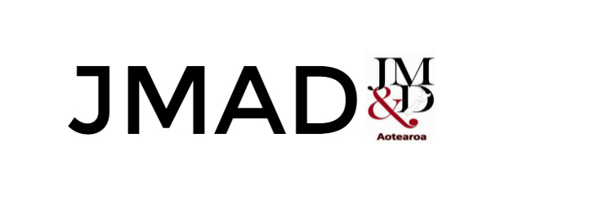

AUT research centre for Journalism, Media and Democracy (JMAD)

[Press release] – Embargo until December 5, 2019, 1.00AM

***The future of our media placed in the hands of private equity***

The New Zealand media sector is facing the biggest structural changes in a decadeas the whole news ecosystem is in serious trouble. This means that we are likely to see shrinking number of media companies in 2020. The government is mulling an entire restructure of public broadcasting. At the same time, the future of New Zealand’s commercial media sector has been firmly placed in the hands of private equity firms and investment managers.

Since 2011, *JMAD New Zealand media ownership reports* have highlighted the vulnerabilities of media companies’ financial ownership structures. Now, the JMAD’s 2019 report warns that the shape of our commercial broadcasting sector is in the hands of American investment manager Oaktree Capital and Sydney-based Quadrant Private Equity.

* The chickens have come home to roost. MediaWorks is becoming 100% owned by investment managers and private equity firms. The future of MediaWorks is in the hands of Australian and American financiers who are looking for the best deal for themselves, says the reports lead-author Dr Merja Myllylahti.
* Additionally, NZME is in talks with Australian Nine to buy *Stuff,* and the company’s fate will be decided by the Nine and NZME financial shareholders, she adds.

The JMAD 2019 report finds New Zealand media outlets have expanded their pay models. This year the *NZ Herald* launched a paywall, and other outlets introduced voluntary payments and memberships. Of the main media outlets, *Stuff* remains the only one without any kind of digital reader payments. The JMAD report finds that the *NZ Herald’s* paywall is a ‘soft’ one which has not substantially reduced the news site’s traffic. On the other hand, RNZ has gained in traffic most likely due to its partnerships with other media organisations.

**Contact:** To find more or to interview Dr Merja Myllylahti, contact: [mmyllyla@aut.ac.nz](mailto:mmyllyla@aut.ac.nz) or @MyllyMe or 09-921999 #7908

-ENDS-

**About:**

JMAD is AUT research center for Journalism, Media and Democracy, and its reports are publicly available at AUT online**:** <http://www.aut.ac.nz/study-at-aut/study-areas/communications/research/journalism,-media-and-democracy-research-centre/journalists-and-projects/new-zealand-media-ownership-report>